**Name: _____________________**

**Unit 6 Circles and Area Review**

|  |
| --- |
| **Fill out the formulas below. (You may want to write these on a notecard!!)**  **Circumference = ________________**  **Area of a Circle = ___________**  **Perimeter of a semicircle = _____________________**  **Area of a semicircle = _______________________** |

Find the circumference of each circle.

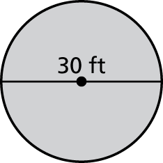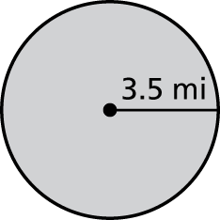1. 2.

1.)_______________

2.)_______________

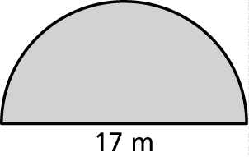Find the perimeter of the semicircle.

3.

3.)_______________

Find the area of the circle.

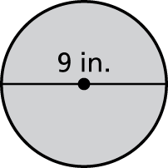4.

4.)_______________

Find the area of the semicircle.

5.



16 in

5.)_______________

6. If you are given the circumference of a circle, describe how you would find the diameter.

7. Find the area of the figure.

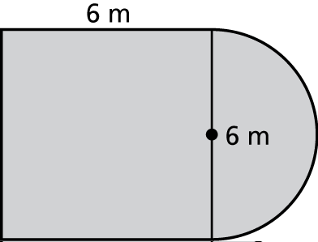

8. Find the area.

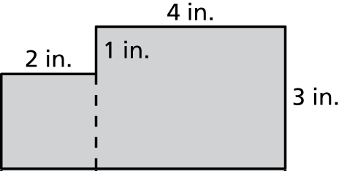

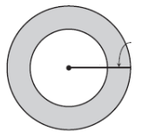9. Find the area of the shaded region.

3 ft

7 ft

10. Use the circle above. If you were to outline the small inner circle with tape, how much tape would you need to go around the small circle?

**Answer Key:**

|  |  |  |  |  |  |  |  |  |  |
| --- | --- | --- | --- | --- | --- | --- | --- | --- | --- |
| 1.) 21.98 mi | 2.) 94.2 ft | | 3.) 43.69 m | | 4.) 63.585 in2 | | 5.) 100.48 in2 | | 6.) Divide circumference by π |
| 7.) 50.13 m2 | | 8.) 16 in2 | | 9.) 160.14 ft2 | | 10.) 43.96 ft | |