Name: _______________________

**Unit 6: Transformations Review Handout**

1.) Graph triangle A(3, -2), B(1, -4), C(1,-1) 2.) Graph ∆ TWK as vertices T(2, 1), W(1, 4)

and its reflection over the y-axis, then rotate K(3,3). Graph the triangle and translate it

the image 90° clockwise. (x, y) (x + 2, y – 3) then reflect it over the

y-axis.

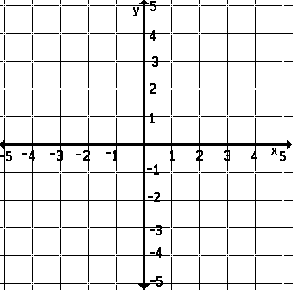

A’:_________ B’: ___________ C’:________ T’:_________W’:_________ K’:_________

A”_________ B” ___________ C”________ T”_________W”_________ K”_________

3.) Graph ∆ DEF: D(1,2), E(3,1), 4.) Graph triangle PAT: P(2,2), A(2,4)

F(2, 4) and then rotate the image T(0,4), and its image with a scale factor of

180 ˚. Then translate it 3 units up and ½. Then reflect it over the x axis.

1 unit to right.



D’_______ E’_______ F’_______ P’_______ A’_______ T’_______

D”_______ E”_______ F”_______ P”_______ A”________ T”_______

**Find the missing variables using similar figures. Round to the nearest tenth if necessary.**

5.) 6.)

10 cm

x

14 cm

5 cm

3x

8 cm

12 cm

4 cm

5.) x = _____________

6.) x = _____________

X

Y

Z

M

N

O

ΔMNO and ΔXYZ are congruent.

7.) Which angle of ΔMNO corresponds to Y? 7.) __________

8.) Which angle of ΔXYZ corresponds to O? 8.) __________

9.) Which side of ΔMNO corresponds to side $\overline{YZ}$? 9.) __________

Answer Key:

|  |  |  |  |  |  |  |  |
| --- | --- | --- | --- | --- | --- | --- | --- |
| 1.) A’ (-3, -2) B’ (-1, -4) C’ (-1, -1)  A’’ (-2, 3) B”(-4, 1) C” (-1, 1) | | 2.) T’ (4, -2) W’ (3, 1) K’ (5, 0)  T” (-4, -2) W” (-3, 1) K” (-5, 0) | | | 3.) D’ (-1, -2) E’ (-3, -1) F’ (-2, -4)  D” (0, 1) E” (-2, 2) F” (-1, -1) | | |
| 4.) P’ (1, 1) A’ (1, 2) T’ (0, 2)  P” (1, -1) A” (1, -2) T” (0, -2) | 5.) 5.6 cm | | 6.) x = 2.5 | 7.) N | | 8.)  Z | 9.) $\overline{NO}$ |