Name: _____________________________ Period: __________ Date: ___________
Unit 5 Review Handout
Directions: Show ALL OF YOUR WORK!! Circle your answers.
Solve using substitution.
1.) y = 6x – 11 2.) -3x – 3y = 3
-2x – 3y = -7 y = -5x – 17

Solve using elimination.
3.) -4x + 9y = 9 4.) -4x – 2y = 14
x – 3y = -6 -10x + 7y = -25

Solve using any method.
5.) -14 = -20y – 7x 6.) 3 + 2x – y = 0
10y + 4 = 2x -3 – 7y = 10x

Write the system and solve.
7.) You have a jar of pennies and quarters. You want to choose 15 coins that are worth exactly $2.31. Write a system of equations to model the situation. How many pennies and quarters do you choose?

8.) In a chemistry lab, you have two vinegars. One is 5% acetic acid and one is 6.5% acetic acid. You want to make 200 mL of vinegar with 6% acetic acid. How many milliliters of each vinegar do you need to mix together?

Solve the system of inequalities by graphing.
9.) y ≤ -x – 2 10.) 4x + y < 2
y ≥ -5x + 2 y > -2
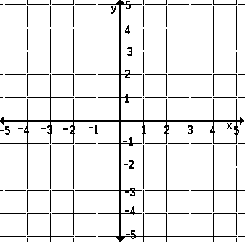

Solve equation by graphing.
11.) $\left|-x+4\right|$ = $\left|2x-2\right|$

ANSWERS:
1.) ( 2, 1 ) | 2.) (-4,3) | 3.) ( 9, 5) | 4.) (-1,-5) | 5.) ( 2, 0)
6.) (-1, 1) | 7.) quarters =9 pennies = 6 | 8.) 6.5% = 66.7  5%= 133.3 | 11.) x = 2 and x =-2

