Name: ____________________________________ Period: _______ Date: _______

**Unit 4 Review Handout**

**Evaluate the function.**

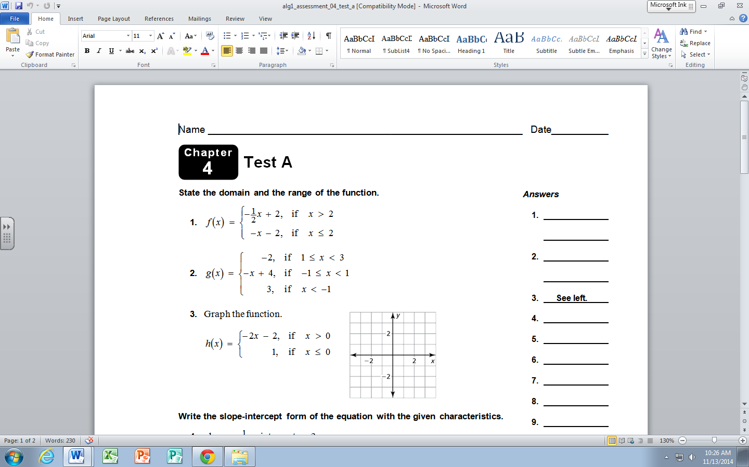1.) 2.)

A.) *f*( 5) B.) *f*(-1) C.) *f*(2) A.) *f*(2) B.) *f*(-1) C.) *f*(-3)



**Graph the function.**

3.)

**Write the slope – intercept form of the equation with the given characteristics.**

4.) slope = - $\frac{3}{2}$; passes through (-4,7) 5.) slope= 2; y-intercept = 3

6.) perpendicular to line y= - 2x – 7 ; passes through (-3, 10)

7.) parallel to line y = $\frac{3}{5}$ x – 8 ; passes through (0, -3)

**Write a rule for the arithmetic sequence. Then find the 50th term.**

8.) 9, 13, 17, 21, . . . 9.) 5, 5.3, 5.6, 5.9, . . .

**Scatterplot and line of best fit.**

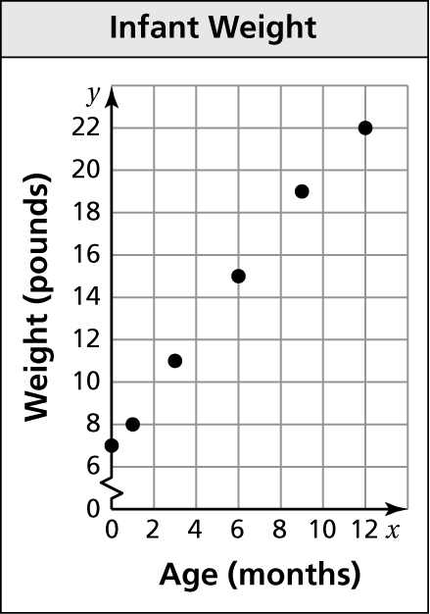10.) The scatter plot shows the weights y of an infant

from birth through x months.

a. At what age did the infant weigh 11 pounds?

b. What was the infant’s weight at birth?

c. Draw a line that you think best approximates

the points.

d. Write an equation for your line.

e. Use the equation to predict the weight of the

infant at 18 months.

f. Does the data show a positive, a negative, or no relationship?

**Answers:**

|  |  |  |
| --- | --- | --- |
| 1.) a.) -0.5 b.) -1 c.) -4 | 2.) a.) -2 b.) 5 c.) 3 | 3.) see graph |
| 4.) y = - $\frac{3}{2}$ x + 1 | 5.) y = 2x + 3 | 6.) y = ½ x + 11 ½ |
| 7.) y = $\frac{3}{5}$ x - 3 | 8.) A(n) = 9 + (n - 1)4 205 | 9.) A(n) = 5 + ( n – 1).3 19.7 |
| 10.) a.) three months  b.) 7 lbs d.) y = 1.3x + 7  e.) 30.4 lbs f.) positive |



3.)