Name: ____________________________________ Period: _______ Date: _______
Unit 3 Review Handout
Write a function rule for the table.
x | f(x)
2 | –8
3 | –12
4 | –16
5 | –20
x | f(x)
3 | 7
4 | 8
5 | 9
6 | 10
1.) 2.)

f(x) = ______________________ f(x) = ________________________

3.) Write a function and solve. The amount of a person’s paycheck varies directly with the number of hours worked. For 16 hours of work, the paycheck is $124.00. How many hours would you have to work to make $300?

Is the relation a function and determine whether the function is linear or nonlinear.
x | 1 | 3 | 5 | 3
y | 4 | 2 | 0 | -2
4.) x = -2 5.) x – 3y = 9 6.)

Evaluate the function when x = -2, 0 and 3
7.) b(x) = -2x – 4 8.) h(x) = $\left|-x+5\right|$

Graph the linear equation.
9.) x – 3y = 6 10.) x = -4
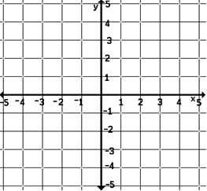
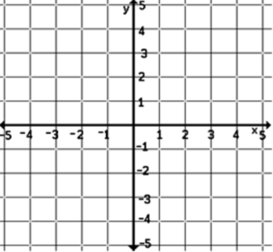

Find the slope, x–intercept and y–intercept of the line.
11.) 2x + 3y = 6 12.) $\frac{1}{2}$x + y = -8

Slope=______ x-int = _______ y-int=_______ Slope=______ x-int = _______ y-int=_______

Express in standard form.
13.) 8 – 2y = 6(x – 4y)

Graph.
14.) y = $\left|x-3\right|$ - 2 15.) y = $\left|x\right|$ + 1

Answers:
1.) f(x) = -4x | 2.) f(x) x + 4 | 3.) 16x= 124 x = 7.75; f(x) 7.75x;  7.75x = 300  39 hours | 4.) Not function, linear | 5.) function, linear
6.) not function, nonlinear | 7.) 0, -4, -10 | 8.) 7, 5 , 2 | 9.) y= $\frac{1}{3}$x – 2 | 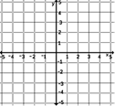  10.)
11.)Slope= -$\frac{2}{3}$  x-int=(3,0)  y-int=(0,2) | 12.) Slope= -$\frac{1}{2}$  x-int=(-16,0)  y-int=(0,-8) | 13.) 6x – 22y = 8 | 14.) | 15.)

