Section 9.1: Surface Area of Prisms Homework Day 2

Find the surface area.
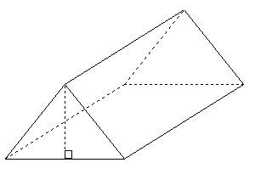  1.) Find surface area.  11 in  5 in  6 in  8 in  8 in | 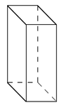2.) Find surface area.  8 in  20 in  7 in  11 in  5 in  6 in
3.) Find surface area.  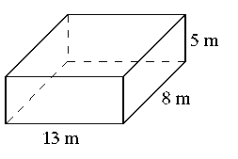 | 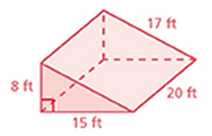  4.) Find surface area.
5.) One can of frosting covers about 280 square inches. Is one can of frosting enough to frost the cake? Show your math and explain your reasoning.  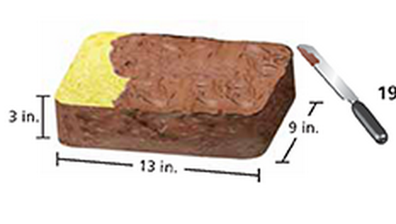 | 6.) Find surface area.  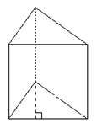  3 in  10 in  8 in  5in  7 in
7.) The outsides of purple traps are coated with glue to catch emerald ash borers. You make your own trap in the shape of a rectangular prism with an open top and bottom. What is the surface area that you need to coat with glue?
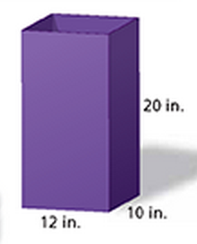

9.1 Homework Day 2:
1.) 261 in² | 2.) 712 in² | 3.) 418 m² | 4.) 920 ft² | 5.) Yes: SA = 249 in² (Don’t frost the bottom!)
6.) 221 in² | 7.) 880 in²

