Name Date

Similar Figures Homework Day 2

2.5

Tell whether the two figures are similar. Explain your reasoning.

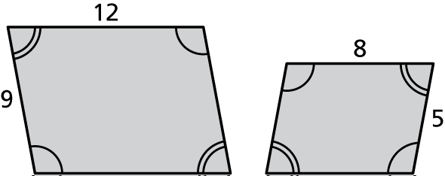 1. 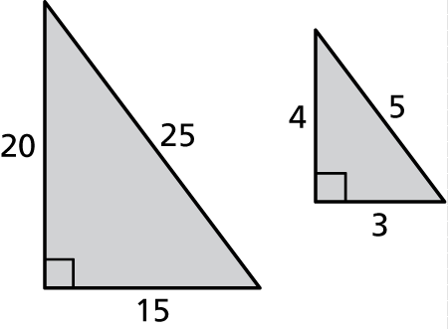 2.

3. In your classroom, a dry erase board is 8 feet long and 4 feet wide. Your teacher makes individual dry erase boards for you to use at your desk that are 11.5 inches long and 9.5 inches wide. Are the boards similar?

4. You have a 4 x 6 photo of you and your friend. You order a 5 x 7 print of the photo. Is the new photo similar to the original?

|  |  |
| --- | --- |
| 5. The triangles are similar. Find x.  9 m  x  7 m  4 m m | 6. The triangles are similar. Find x and y.  12 m  15 m  y  x  5 m  3 m |