Name Date

Similar Figures Homework Day 1

2.5

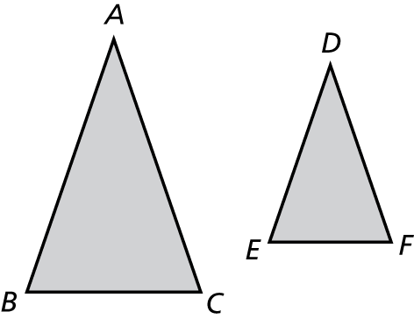 1. Name the corresponding angles and the corresponding sides of the   
similar figures.

Sides: Angles:

_____________ _____________

_____________ _____________

_____________ _____________

2. Tell whether the two figures are similar. Explain your reasoning.

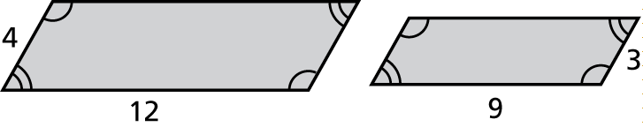

3. The rectangular traffic sign is 18 inches wide and 8 inches tall. The rectangular realtor sign is 27 inches wide and 10 inches tall. Are the signs similar?

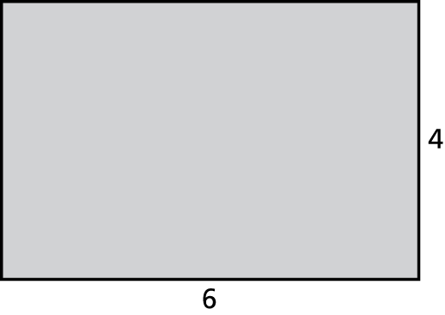 4. If each side length of the rectangle is increased by 2, is the new rectangle similar to the original?

5. Which of the following card dimensions are similar rectangles?

2 in. by 5 in. 3 in. by 6 in.

1 in. by 3 in. 1 in. by 2.5 in.

6. The triangles are similar. Find the dimensions of x and y.

10 m

12 m

7 m

x

21 m

y